TrustTheTickets.com  
Detailed Design Document

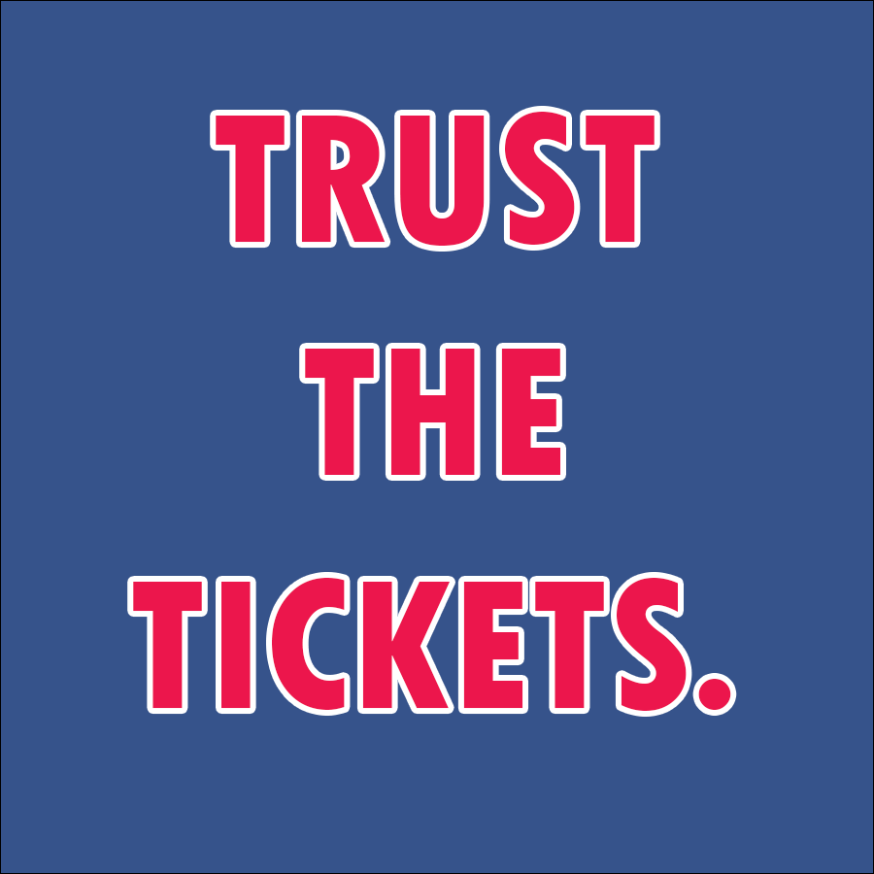

Initial Draft Date: October 9th, 2017

Created by:

Anthony Orio

Christopher McKane

Curtis Baillie

Derek Gaffney  
Jon D’Alonzo

Thomas Harker

<https://github.com/JonDalonzo/Senior-Project>

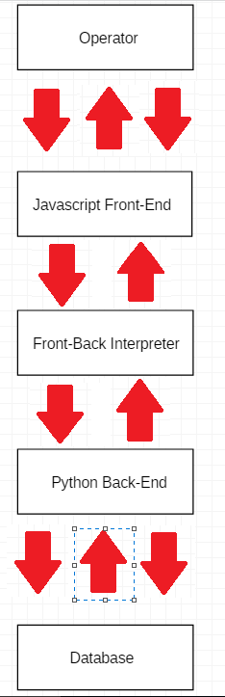

Here lies the general flow of communication throughout the website. The operator will interact with the **Javascript Front-End**, which consists of many methods for each part of website. The three arrows demonstrate that the **Javascript Front-End** can communicate with **the Front-Back Interpreter** in many different ways. This includes methods for transactions, displaying tickets and registering accounts on the website. The **Front-Back Interpreter**, which consists of both Javascript and Python code. The Front-Back Interpreter is the central interface that will be used when calling methods within the Python code. The calls will be passed to Python in this interface and the python will return its data to the front end through this interface upon calls that make requests for data. The single IN and OUT arrows show how communication components can only occur through one path. The **Python Back-End** is responsible with handling all data related activities, such as communicating with the Database and performing operations that the user requests through the **Javascript Front-End**. The three arrows show how the **Python Back-End** can communicate with the **Database** through more than one path, as in many Python methods can access or update the **Database**.

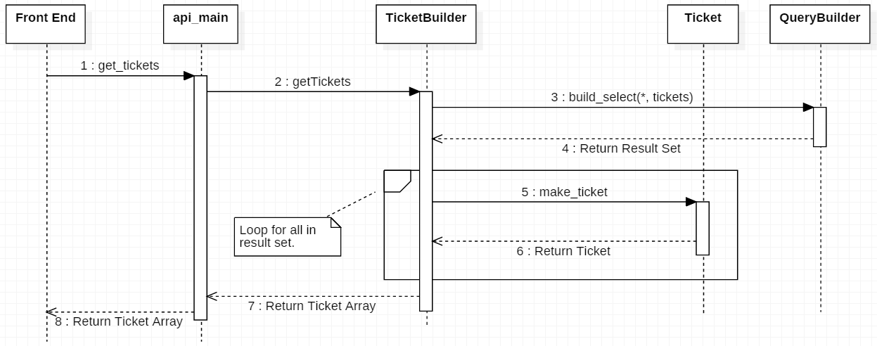

The sequence diagram above shows the flow of operation from each component when retrieving a set of tickets to display in the front end. The Javascript Front-End will access methods in api_main, a part of the Front-Back Interpreter, which will get the tickets from the TicketBuilder. The TicketBuilder will query for the tickets based on the search filters specified by the Operator on the front end. The result will be fetched from the database by the QueryBuilder, who is responsible for accessing and retrieving data from the database. The result set is returned to TicketBuilder, where a loop will make a Ticket object from each row of data returned in the Result Set. The Tickets will be packaged into an array and returned back up to the front end where it will be display to the operator.

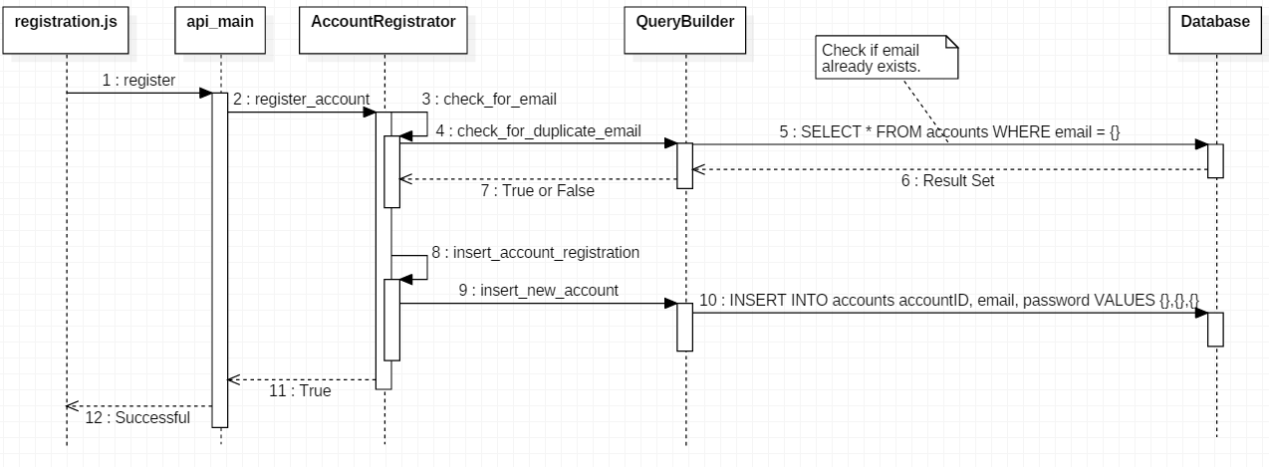

The sequence diagram above depicts the operator action of registering an account successfully on the website. The registration Javascript file will call the register method in api_main. The api_main class will then call the register_account method in AccountRegistrator, where it will check for duplicate emails. To check for duplicates the AccountRegistrator attempts to SELECT the email inputted by the operator from the database through the QueryBuilder. If this is successful, then the email exists otherwise the email does not exist yet and execution can continue. The valid email is then inserted into the database with information. Successful insertion of the new email is replied back to the operator.

Webpages

1. Home
   1. Front page of website with large image of Wells Fargo Center
   2. Scroll down for a calendar view of upcoming games
      1. The list of events on the calendar is drawn from the /events endpoint
      2. Selecting an event on calendar redirects you to a page for purchasing tickets for event
2. Buy
   1. Calendar view
      1. Show all upcoming games on a calendar
      2. The list of events on the calendar is drawn from the /events endpoint
      3. Selecting an event on calendar redirects you to a page for purchasing tickets for individual event
   2. Individual event page
      1. Shows seating chart of arena with available tickets in a panel on the right
         1. Ticket data pulled from the /tickets endpoint
      2. Individual sections are selectable.
         1. Mouseover of a section shows view from that section
            1. Image pulled from /view endpoint
         2. Selecting a section updates the side ticket panel.
      3. Tickets in the ticket panel are selectable
         1. (what happens here?)
3. Sell
4. My Account
   1. Login
      1. Registration

Use Cases:

1. Seller use cases
   1. Seller creates account
   2. Seller modifies account information
   3. Seller deactivates account
   4. Seller inputs payment information in case of non-working tickets
   5. Seller views past transactions (sales)
   6. Seller views expired ticket listings
   7. Seller views deactivated ticket listings
   8. Seller starts listing of tickets
      1. Provides quantity of tickets
      2. Provides section, row, seat number
      3. Provides quantities that people can by at a time (multiples of 2, all tickets together)
      4. Provides disclosures on tickets (obstructed view, no alcohol section, wheelchair accessible, etc)
      5. Provides comments on tickets (Early entry access, Aisle seats, concession credit, etc)
      6. Sets pricing for tickets (all tickets priced the same amount)
      7. Uploads PDF files
   9. Seller modifies listing of tickets
      1. Deactivates listing
      2. Change price of listing
      3. Change quantities of tickets that can be purchased in listing
2. Buyer use cases
   1. Buyer Account Functions
      1. Buyer creates account
      2. Buyer modifies account
      3. Buyer deactivates account
      4. Buyer inputs payment information
      5. Buyer views past transactions
   2. Searching functions
      1. Buyer searches for a specific game
      2. Buyer searches for games a specific team is playing in
      3. Buyer searches for best value (price)
      4. Buyer wants to browse
   3. Buying functions (Once on event listing page)
      1. Buyer filters tickets by quantity available
      2. Buyer filters tickets by aisle seats only
      3. Buyer filters tickets to exclude obstructed view seats
      4. Buyer filters tickets by handicap accessible only
      5. Buyer buys subset of tickets in a group
      6. Buyer buys all tickets in a group
      7. Buyer buys tickets, does not have payment info on file, needs to input at time of sale

Implementation Goals by Mid-Assessment:

1. Display ticket data from the db on event listing page
   1. Add functionality to display all ticket listings for a specific event on the side panel of the seating chart. This involves a call to the db in order to retrieve this information.
   2. Curtis will work on this
2. Add functionality to perform a basic transaction
   1. This would involve allowing a user to select a listing of tickets, choose to buy them, and allow them to input payment information and purchase the ticket listing.
   2. Tom will work on this
3. Add an account registration form
   1. Add functionality so that a user can input their name, address, email, and password and create a user.
   2. Derek will work on this
4. Add a basic filter system on a listing
   1. Add functionality so that when a user clicks on a section, it filters the tickets shown to be only the tickets from that given section.
   2. Jon and Chris will work on this

General Use Case

Handling box seats vs. section seats

System use cases